WORKSHEET 6
Student Name: Aradhya Sharma UID: 25MCC20042
Branch: MCA (CCD) Section/Group: 25MCC-101A
Semester: 2 Date of Performance: 24 FEB 2026

Subject Name: Technical training Subject Code: 25CAP-652

1. AIM
To learn how to create, query, and manage views in PostgreSQL in order to simplify database queries and provide a secure abstraction layer for end users.

2. OBJECTIVES
• To understand data abstraction using SQL views
• To hide complex queries behind virtual tables
• To simplify multi-table queries for reporting
• To implement views for restricted data access
• To strengthen SQL skills used in enterprise systems

3. SOFTWARE REQUIREMENTS
Operating System:
• Windows 10 / 11 / Linux / macOS
Database Management System (DBMS):
• PostgreSQL (version 12 or higher)
SQL Interface:
• pgAdmin 4
OR
• PostgreSQL Command Line Interface (psql)

4. PROCEDURE FOR EXPERIMENT

Step 1: Creating a Simple View for Data Filtering
Objective:
To create a simple view that displays only active employees, hiding the complete employee table structure.
CREATE TABLE departments (
dept_id INT PRIMARY KEY,
dept_name TEXT
);
CREATE TABLE employees (
emp_id INT PRIMARY KEY,
emp_name TEXT,
salary NUMERIC,
status TEXT,
dept_id INT REFERENCES departments(dept_id)
);

CREATE VIEW active_employees_view AS
SELECT emp_id, emp_name, dept_id
FROM employees
WHERE status = 'Active';
SELECT * FROM active_employees_view;
Output:
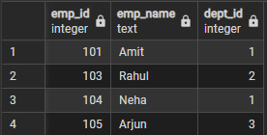

Step 2: Creating a View for Joining Multiple Tables
Objective:
To simplify retrieval of employee and department information using a join-based view.
CREATE VIEW employee_department_view AS
SELECT
e.emp_id,
e.emp_name,
d.dept_name,
e.salary
FROM employees e
JOIN departments d
ON e.dept_id = d.dept_id;

SELECT * FROM employee_department_view;
Output:
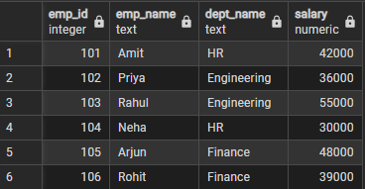

Step 3: Advanced Summarization View
Objective:
To create an aggregated view that provides department-level statistics automatically.
CREATE VIEW department_summary_view AS
SELECT
d.dept_name,
COUNT(e.emp_id) AS total_employees,
AVG(e.salary)::NUMERIC(20, 2) AS avg_salary,
SUM(e.salary) AS total_salary
FROM departments d
JOIN employees e
ON d.dept_id = e.dept_id
GROUP BY d.dept_name;

SELECT * FROM department_summary_view;
Output:
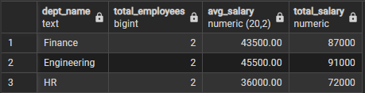

Learning Outcome
This experiment demonstrates the effective use of views in PostgreSQL to provide abstraction, simplify complex queries, and enhance data security.
Students gain practical exposure to view-based design patterns commonly used in:
• Payroll systems
• Reporting and analytics platforms
• Enterprise database security
• Placement-oriented technical interviews

